**Space Invaders Design Document**

# **GAME SPECIFICS**

Genre: 2D Arcade game Re-Creation

Rating: E 10+

Gameplay Loop:

The game will feature an endless cycle of enemy spaceships that the player will fight. Each wave will be pre-determined, as the levels progress, the enemies will get stronger and harder to deal with. The enemy ships will award points to the player, where they will be logged to a leaderboard to view at the end.

# **DEVELOPMENT LIST**

* Player
  + Controls
    - Left/Right Motion
      * Engine Audio
  + Weapon
    - Fire Effect
      * Audio
  + Bullets
    - Impact Effect
      * Audio
  + Health
* Enemies
  + AI
    - Movement Pattern
  + Weapon
  + Bullets
  + Boundaries
  + Health
* Pickups
  + Active Effect(s)
    - Health
    - Damage Boost (Timed)
    - Shooting Speed Boost (Timed)
* Leaderboard
  + Shows Top 5 Previous Scores
    - PlayerPrefs?
* UI Menus (Main, Pause, Settings)
* Game Management, Scene Management
  + Log Score Between Levels
  + Log Wave Counter
  + Level Transition When All Enemies Die
  + Background Music
* Fine-Tuning
  + Play-Testing and Immersion Factor
  + Balancing

Art to Create:

* Background for Levels
  + Space Themed (Duh)
* Player Ship
  + Something simple, White or Blue Scheme?
* Enemy Ship(s)
  + Red/Black/Gold Scheme?
  + 3 Different Ships?
* Pickups
  + “+” – Health
  + Explosion - Damage
  + “>>” - Speed

CONCEPT ART

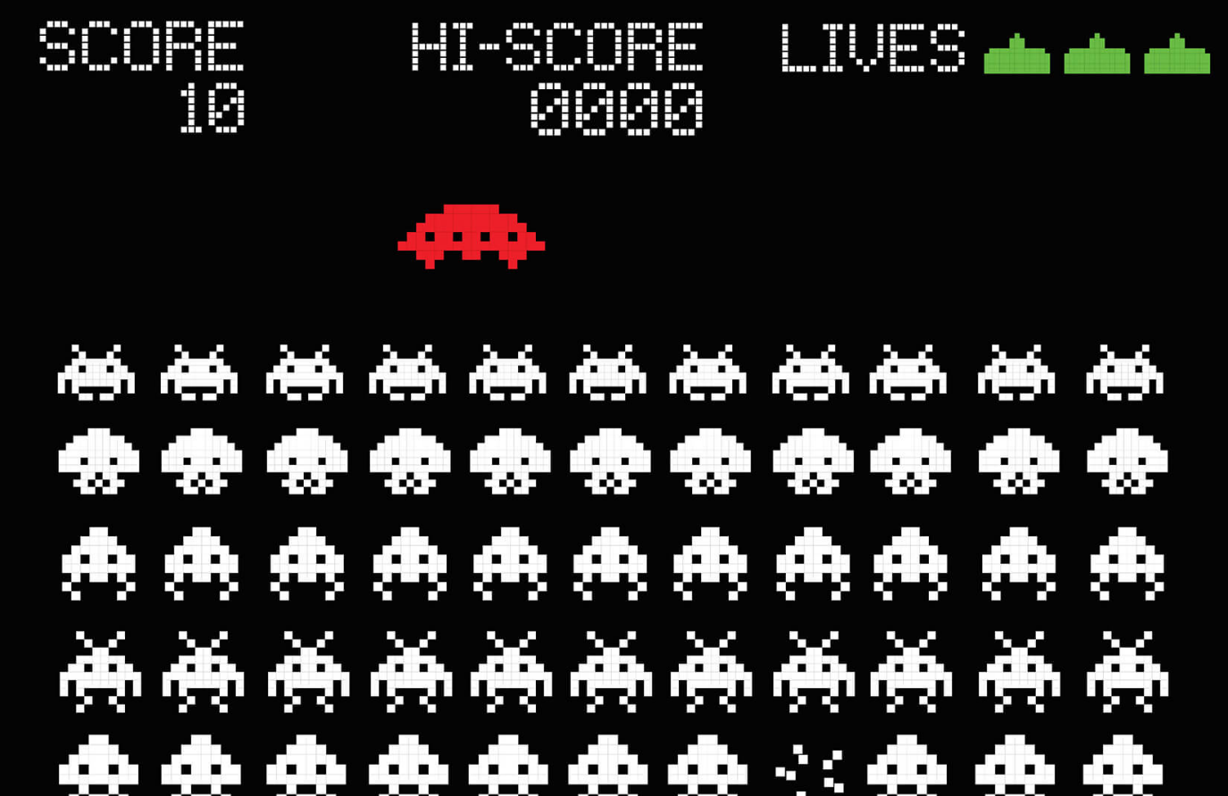

UML CLASS DIAGRAMS

Alpha/Beta [UML Diagrams](https://d.docs.live.net/43d154c33fa54c01/Desktop/Design%20Documentation/Arcade%20Games/Space%20Invaders/Space%20Invaders%20UML%20class%20diagram.xlsx)

TESTING SHEET

Alpha/Beta builds [Testing Sheet](https://d.docs.live.net/43d154c33fa54c01/Desktop/Design%20Documentation/Arcade%20Games/Space%20Invaders/Space%20Invaders%20Testing%20Sheet.xlsx)

Gold/Final build [Testing Sheet](https://d.docs.live.net/43d154c33fa54c01/Desktop/Design%20Documentation/Arcade%20Games/Space%20Invaders/Space%20Wars%20Testing%20Sheet.xlsx)